Lesson 11

Binomial Theorem and Mathematical Induction

sPECIFIC OBJECTIVES:

At the end of the lesson, the student should be able to :

- Recognize patterns in binomial expansions.
- Evaluate a binomial coefficient.
- Expand a binomial raised to a power.
- Find a particular term in a binomial expansion
- Understand the principle of mathematical induction.
- Prove statements using mathematical induction.

11.1 Binomial Theorem

Definition 11.1.1 Patterns in Binomial Expansions

A number of patterns, as follows, begin to appear when we write the binomial expansion of 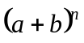, where n is a positive integer.

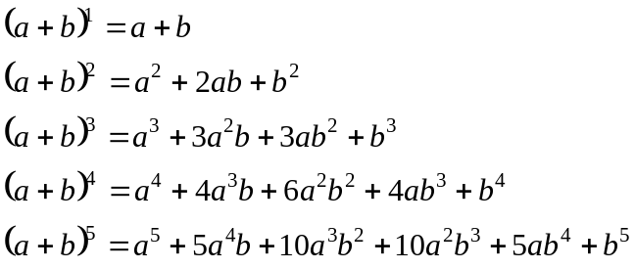
and so on.

Remark:
In each expanded form above, the following can be observed:

- The first term is 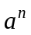 and the exponent on a decreases by 1 in each successive term.
- The last term is 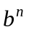and the exponent on b decreases by 1 in each successive term.
- The sum of the exponents on the variables in any term is equal to n.
- There are 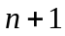 terms in the expanded form of 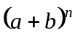.
Definition 11.1.2 Binomial Coefficients

An interesting pattern for the coefficients in the binomial expansion can be written in the following triangular arrangement:

n = 0 1
n = 1 1 1
n = 2 1 2 1
n = 3 1 3 3 1
n = 4 1 4 6 4 1
n = 5 1 5 10 10 5 1
n = 6 1 6 15 20 15 6 1
. . . . . . . .
. . . . . . . . .
This triangular array of coefficients is called the Pascal’s Triangle.

Note: When n is small, the use of Pascal’s triangle is advantageous. However, if n is large or a specific term is desired, the use of Binomial Theorem is more appropriate.

Definition 11.1.3 The Binomial Theorem

The Binomial Theorem provides a formula for expanding expressions of the form , where n is a natural number.

For any binomial 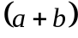 and any natural number n ,

The specific term of a binomial expansion is

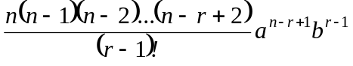

Example 11.1.1 Expand the following by the binomial theorem.

a) 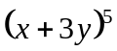 b) 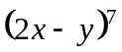

Exercise 11.1.1 Use Binomial Theorem to expand each binomial and express the result in simplified form.

1. 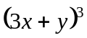 3. 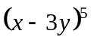
2. 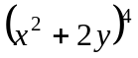 4. 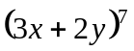

Example 11.1.2 Find the term indicated in each expansion

a) 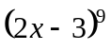; 4th term b) 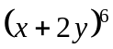; 3rd term

Exercise 11.1.2 Find the term indicated in each expansion.

1. 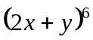; 3rd term 3. 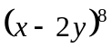; 4th term
2. 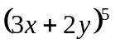; 4th term 4. 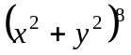; 6th term

Example 11.1.3 Find the 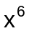- term of the binomial expansion 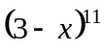.

11.2 Mathematical Induction

Definition 11.2.1 The Principle of Mathematical Induction

Mathematical induction is a powerful method to prove statements about positive integers.

Let 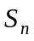 be a statement involving the positive integer n. If
1. 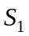 is true, and
- the truth of the statement 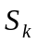 implies the truth of the statement 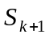, for every positive integer k,
then the statement is true for all positive integers n.

The first condition is called the Basis Step while the second is called the Induction Step.

The Steps in a Proof by Mathematical Induction

Let be a statement involving the positive integer n. To prove that is true for all positive integers n requires two steps.

Step 1 Show that is true.
Step 2 Show that if is assumed to be true, then is also true, for
every positive integer k.

Note: To prove .we work only with the statements , and .

Example 11.2.1 For the given statement : 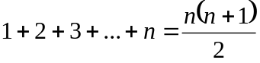, write
the three statements , and .

Solution: :
: 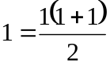
: 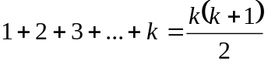

: 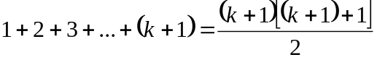
: 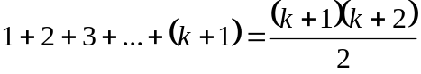

Example 11.2.2 Use mathematical induction to prove that

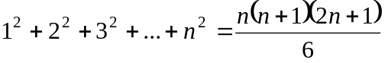
for all positive integers n.

Solution:

Step 1 : Show that is true. Statement is
: 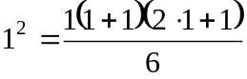
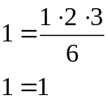
is true.

Step 2: Show that if is true, then is true.
: 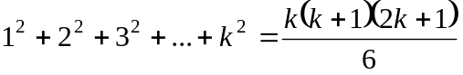
implies the truth of
: 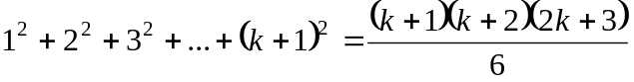
Work with which is assumed to be true.
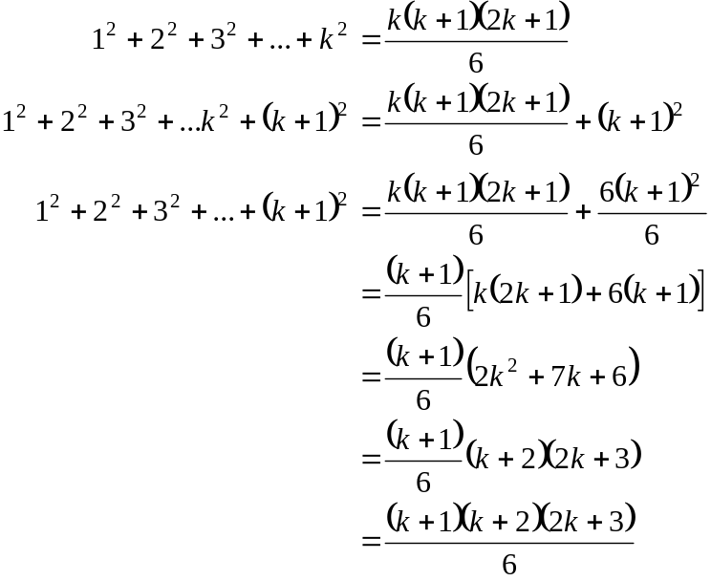

Therefore, is true for every positive integer n.

Exercise11.2.1 Use mathematical induction to prove that each statement is true for every positive integer n.

1. : 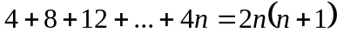
2. : 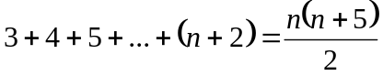
3. : 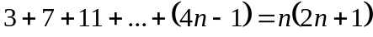
4. 2 is a factor of 